WB-0BC-2NT
2.4Ghz 200m Elevator Wireless Bridge

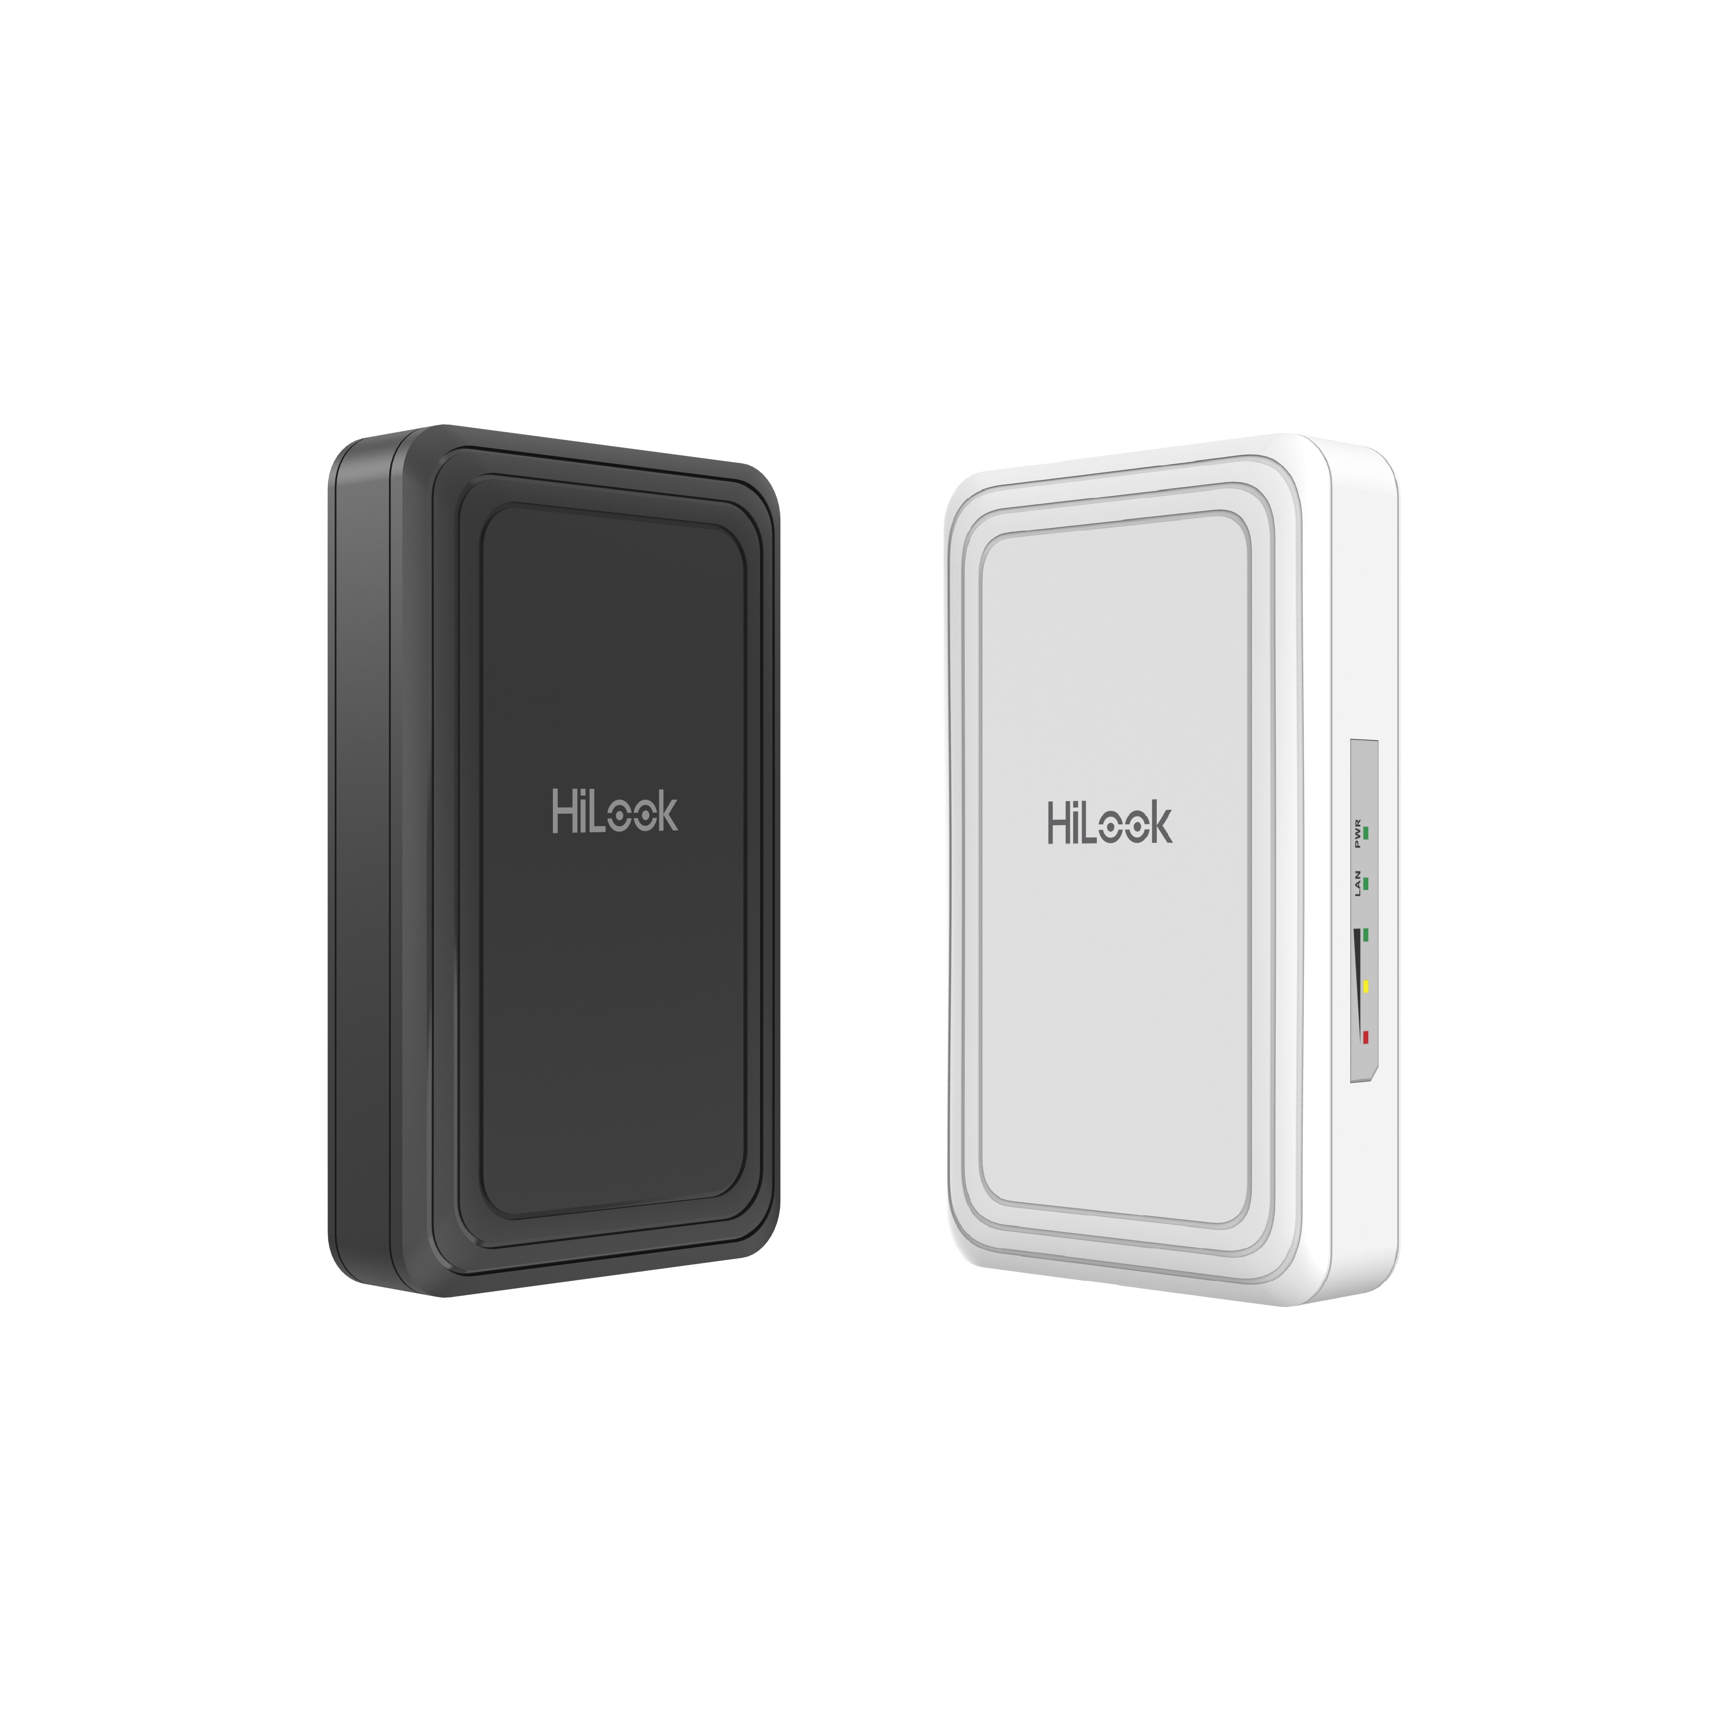

The dual wireless bridge can be applied in industries, such as wireless video security, railway, transportation, power and other industries, wireless video/data transmission, wireless coverage, carrier wireless backbone network construction, Wi-Fi wireless coverage, rural information construction, and wireless network coverage. The long-distance transmission of the device can guarantee multi-channel HD video transmission.

- Up to 200 m wireless transmission distance
- 802.11n wireless bridge
- Ideal Solution for Elevator Connection
- Plug and Play

- Specification
Wireless Parameter
Max. Transmission Rate of Air Interface | ≤ 72 Mbps
Wireless Standard | IEEE 802.11b/g/n
Working Frequency Band | 2400 MHz ~ 2483.5 MHz
Antenna Gain | 7 dBi
Antenna Angle | (H) Beamwidth [3 dB] 50° (V) Beamwidth [3 dB] 50°
Transmitting Power | 16 dBm @11b 1Mbps (Note: Transmitting power may vary with local regulations.)
Receiving Sensitivity | -85±2dBm @HT20 MCS0
Throughput Rate | PTP: 30 Mbps/0.2 KM(HT20)
Hardware Parameter
Network Interface | 1 × 10/100 Mbps RJ45 ports
LED Indicator | Power indicator,LAN indicator,Signal intensity indicator
Reset | Hardware resetting button
Power Supply | 12-24 VDC Passive PoE
Software Function
Channel Width | 10/20 MHz
Channel Selection | Auto/manual selection
Network Protocol | NTP (network time synchronization),SADP (auto search for IP address),SSH (debugging)
Security Mode | WPA2-PSK
Security Mechanism | Wireless network name hidden
Management Method | Web
Upgrade | Web
System Log | Syslog
Application Function | Support adaptive frequency hopping. Support fault self-healed.
General
Product Dimensions (W × H × D) | 80 mm × 41.94 mm × 136 mm (3.15'' × 1.65'' × 5.35'')
Package Dimensions (W × H × D) | 256 mm × 231 mm × 86 mm (10.07" × 9.09" × 3.38")
Net Weight | 0.12 kg (0.26 lb) per device
Gross Weight | 0.7 kg (1.54 lb)
Packing List | Wireless Bridge × 2, Power Adapter (12 VDC, 1 A) × 2, 10/100 Mbps PoE Injector × 2, Binding Tape × 4, Quick Start Guide ×1, Regulatory Compliance and Safety Information × 1
Packing Method | Packing in pairs
Working Temperature | -30 °C to 70 °C (-22 °F to 158 °F)
Working Humidity | 5% to 95% (no condensation)
Storage Temperature | -40 °C to 80 °C (-40 °F to 176 °F)
Storage Humidity | 5% to 95% (no condensation)

Installation Mode | Pole Mounting
Ingress Protection | IP41
Power Consumption | 1 W for typical (1-ch 2MP IPC), Max. 2 W
Approval
EMC | CE-EMC (EN 55032: 2015+A11: 2020, EN IEC 61000-3-2: 2019, EN 61000-3-3: 2013+A1: 2019, EN 50130-4: 2011+A1: 2014, EN 55035: 2017+A11: 2020)
Safety | CB (AMD1:2009, AMD2:2013, IEC 62368-1: 2014 (Second Edition)), CE-LVD (EN 62368-1: 2014+A11: 2017)
Chemistry | CE-RoHS (2011/65/EU),WEEE (2012/19/EU),Reach (Regulation (EC) No.1907/2006)
Radio | EN 301 893,EN 300 440,EN 62311,EN 301 489-3,EN 301 489-17

- Typical Application
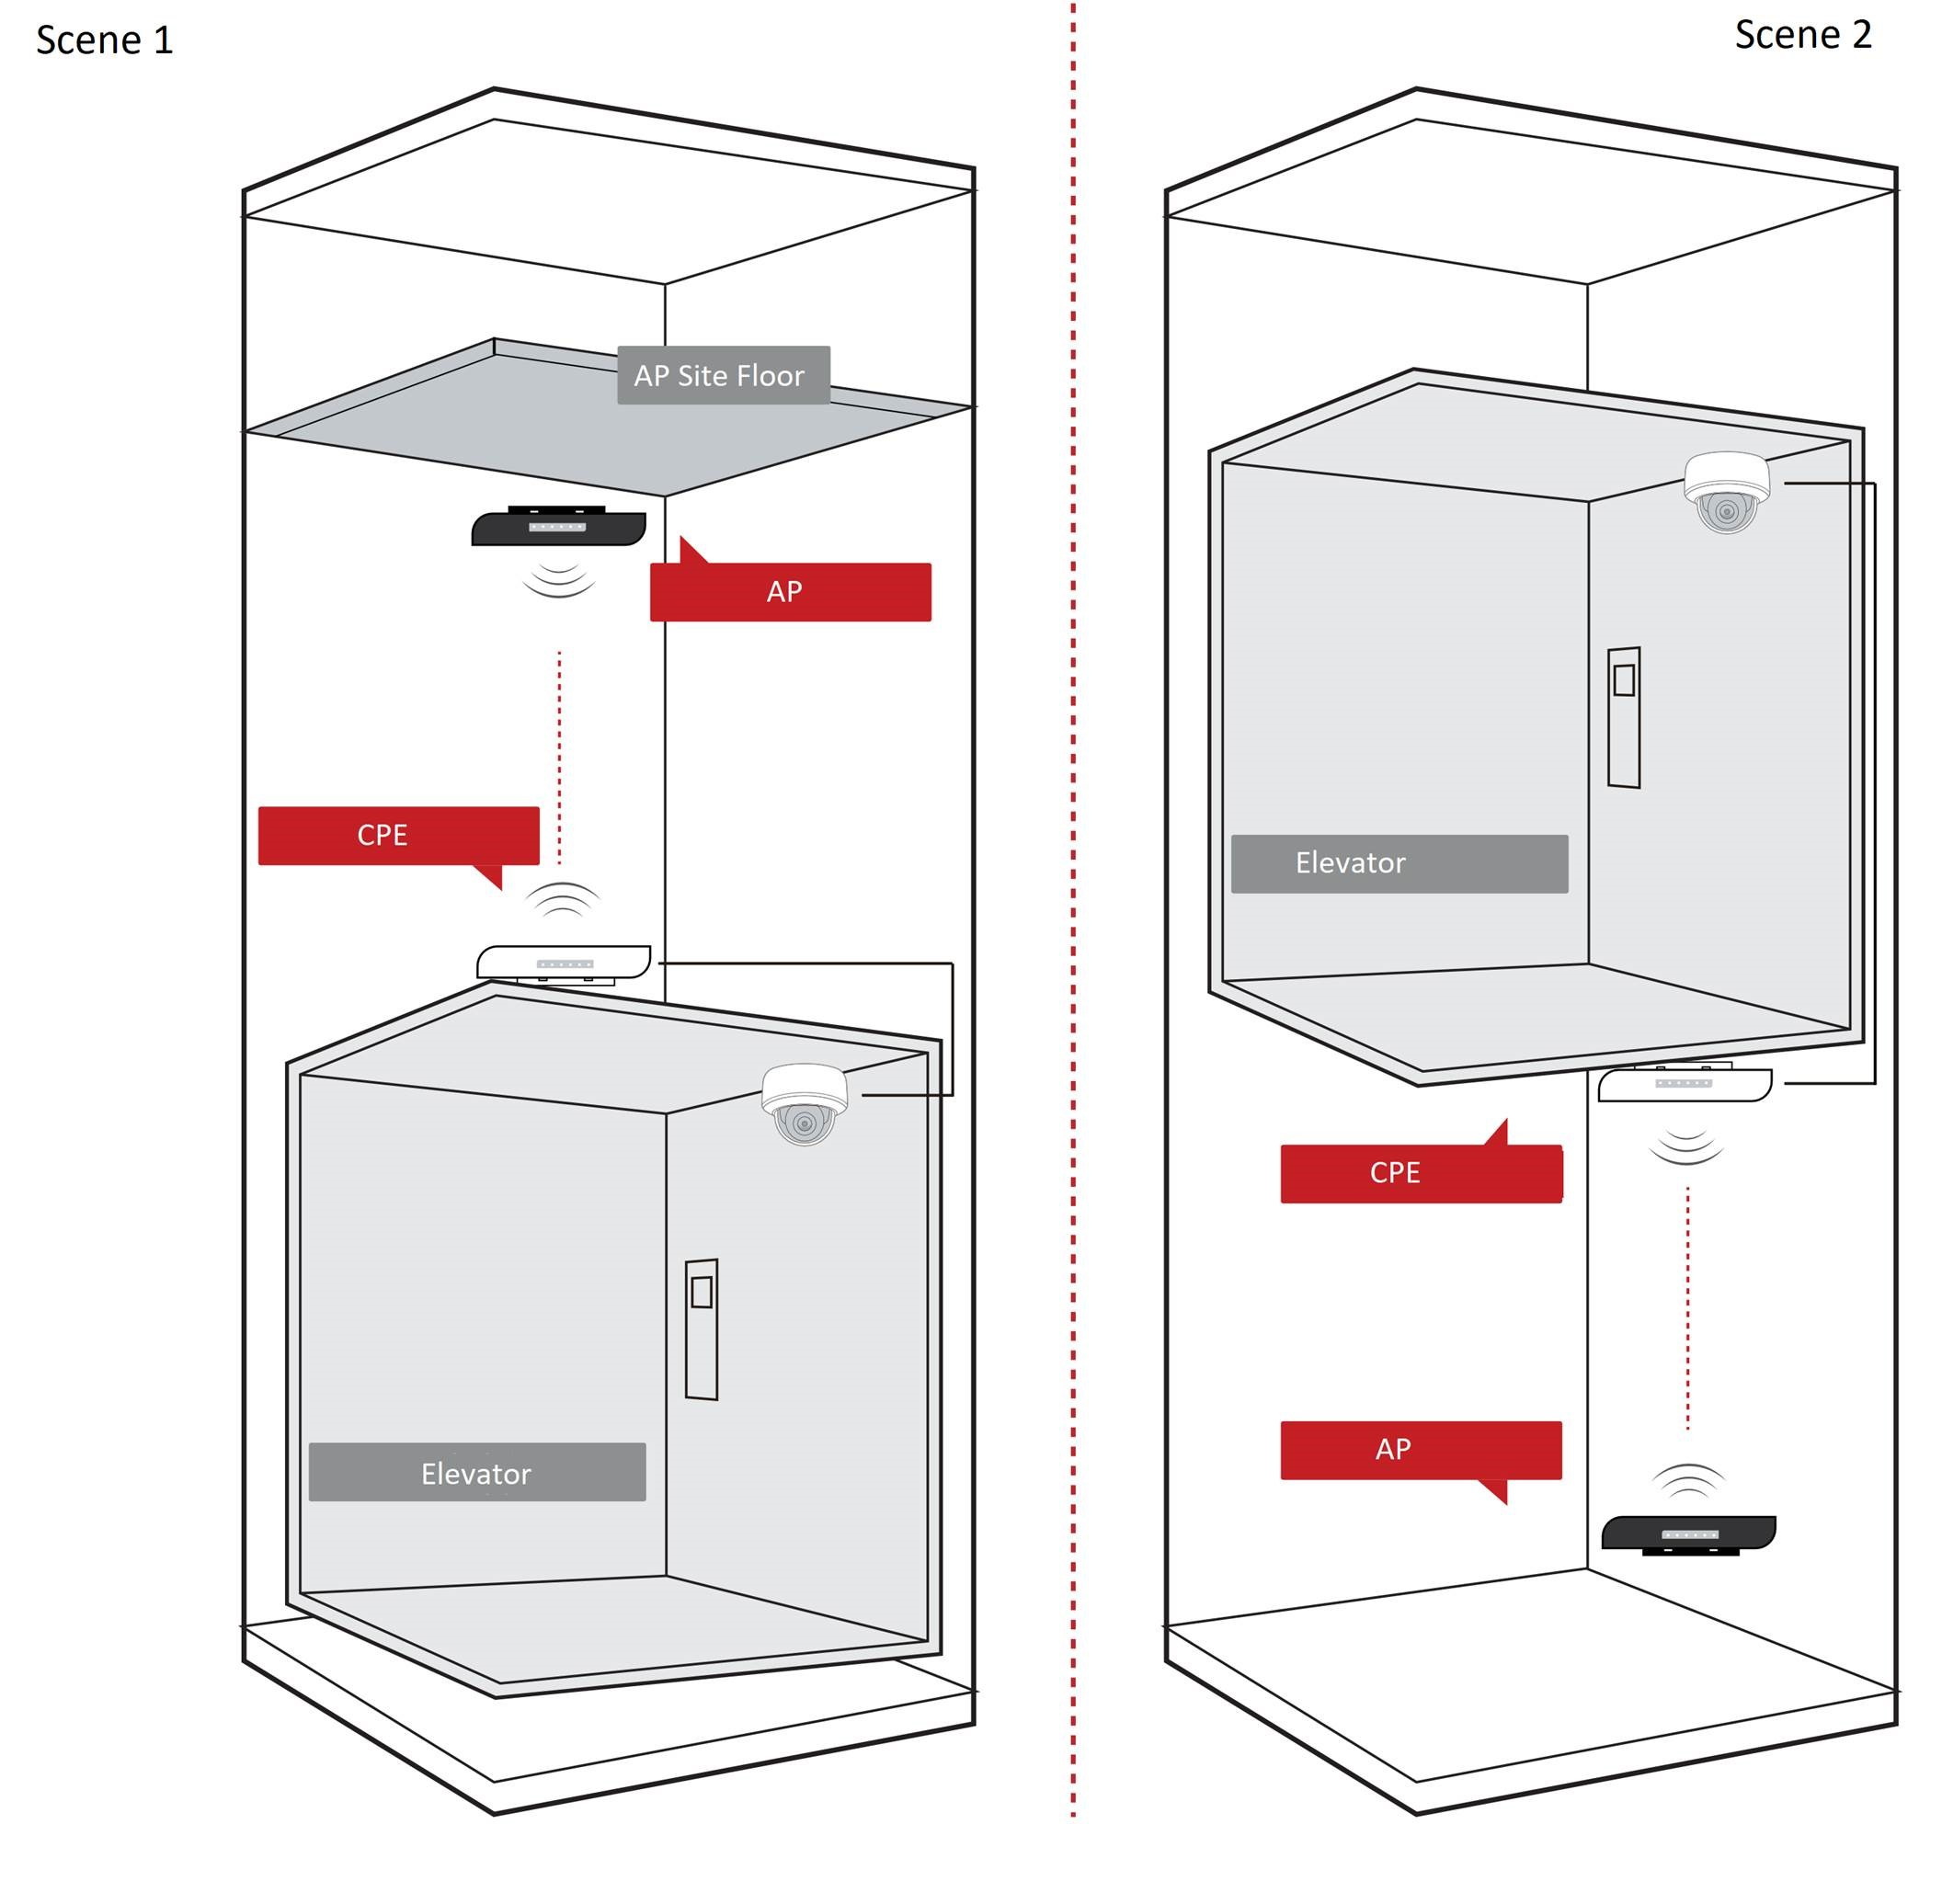

- Physical Interface
No. | Interface/Button | Description
1 | Reset | Long press for 4 seconds to restore to factory settings.
2 | PoE/LAN | The 10/100 Mbps adaptive RJ45 port, also can be used as a PoE port.
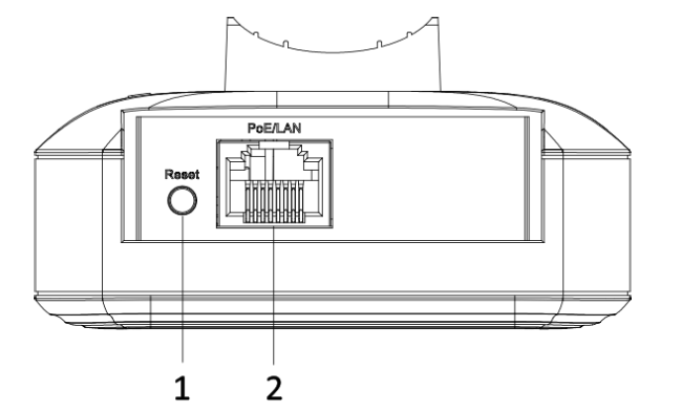

- Available Model
WB-0BC-2NT

- Dimension
